1. **REACTJS-HOL**

**Program**

**App.js**

import React from 'react';

function App() {

return (

<div>

<h1>Welcome to the first session of React</h1>

</div>

);

}

export default App;

**Output**

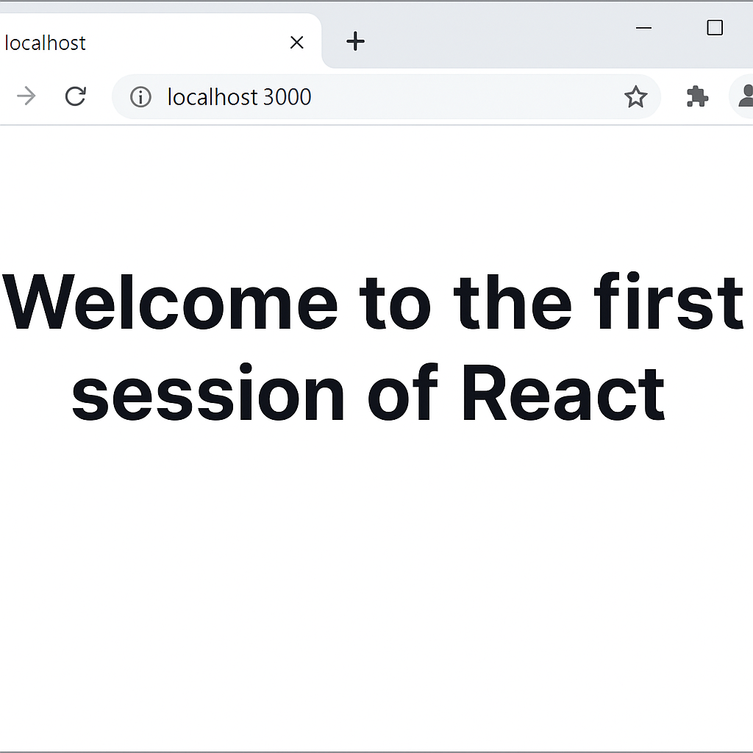

1. **REACTJS-HOL**

**Program**

**Home.js**

import React, { Component } from 'react';

class Home extends Component {

render() {

return (

<div>

<h2>Welcome to the Home page of Student Management Portal</h2>

</div>

);

}

}

export default Home;

**About.js**

import React, { Component } from 'react';

class About extends Component {

render() {

return (

<div>

<h2>Welcome to the About page of the Student Management Portal</h2>

</div>

);

}

}

export default About;

**Contact.js**

import React, { Component } from 'react';

class Contact extends Component {

render() {

return (

<div>

<h2>Welcome to the Contact page of the Student Management Portal</h2>

</div>

);

}

}

export default Contact;

import React, { Component } from 'react';

class Contact extends Component {

render() {

return (

<div>

<h2>Welcome to the Contact page of the Student Management Portal</h2>

</div>

);

}

}

export default Contact;

**App.js**

import React from 'react';

import Home from './Components/Home';

import About from './Components/About';

import Contact from './Components/Contact';

function App() {

return (

<div>

<Home />

<About />

<Contact />

</div>

);

}

export default App;

**Output**

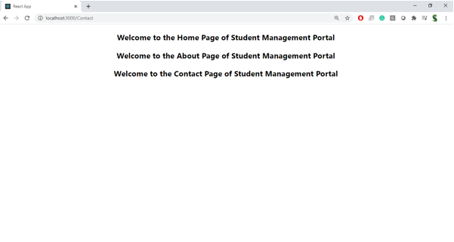

**3. REACTJS-HOL**

**CalculateScore.js**

import React from 'react';

import '../Stylesheets/mystyle.css';

const percentToDecimal = (decimal) => {

return (decimal * 100).toFixed(2) + "%";

};

const calcScore = (total, goal) => {

return percentToDecimal(total / goal);

};

export const CalculateScore = ({ Name, School, total, goal }) => (

<div className="formatstyle">

<h1 style={{ color: 'brown' }}>Student Details:</h1>

<div className="Name">

<b><span>Name: </span></b>

<span>{Name}</span>

</div>

<div className="School">

<b><span>School: </span></b>

<span>{School}</span>

</div>

<div className="Total">

<b><span>Total: </span></b>

<span>{total} Marks</span>

</div>

<div className="Score">

<b>Score: </b>

<span>{calcScore(total, goal)}</span>

</div>

</div>

);

export default CalculateScore;

mystyle.css

.formatstyle {

text-align: center;

font-size: large;

}

.Name {

font-weight: 300;

color: blue;

}

.School {

color: crimson;

}

.Total {

color: darkmagenta;

}

.Score {

color: forestgreen;

}

App.js

import React from 'react';

import './App.css';

import CalculateScore from './components/CalculateScore';

function App() {

return (

<div>

<CalculateScore

Name="Steeve"

School="DNV Public School"

total={284}

goal={3}

/>

</div>

);

}

export default App;

**Output:**

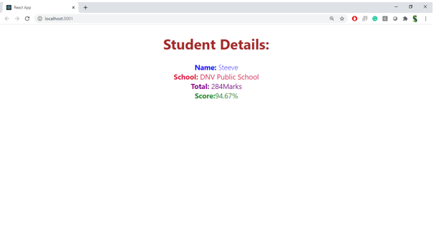

**4.REACTJS-HOL**

**Post.js**

class Post {

constructor(id, title, body) {

this.id = id;

this.title = title;

this.body = body;

}

}

export default Post;

**Posts.js**

import React from 'react';

import Post from './Post';

class Posts extends React.Component {

constructor(props) {

super(props);

this.state = {

posts: [],

error: null

};

}

loadPosts() {

fetch('https://jsonplaceholder.typicode.com/posts')

.then(response => {

if (!response.ok) {

throw new Error('Failed to fetch posts');

}

return response.json();

})

.then(data => {

const postList = data.map(

item => new Post(item.id, item.title, item.body)

);

this.setState({ posts: postList });

})

.catch(error => {

this.setState({ error });

});

}

componentDidMount() {

this.loadPosts();

}

componentDidCatch(error, info) {

alert('Error: ' + error.toString());

}

render() {

const { posts, error } = this.state;

if (error) {

return <p style={{ color: 'red' }}>Error loading posts: {error.message}</p>;

}

return (

<div>

<h1>Posts</h1>

{posts.map(post => (

<div key={post.id}>

<h3>{post.title}</h3>

<p>{post.body}</p>

<hr />

</div>

))}

</div>

);

}

}

export default Posts;

**App.js**

import React from 'react';

import './App.css';

import Posts from './Posts';

function App() {

return (

<div className="App">

<Posts />

</div>

);

}

export default App;

**output:**

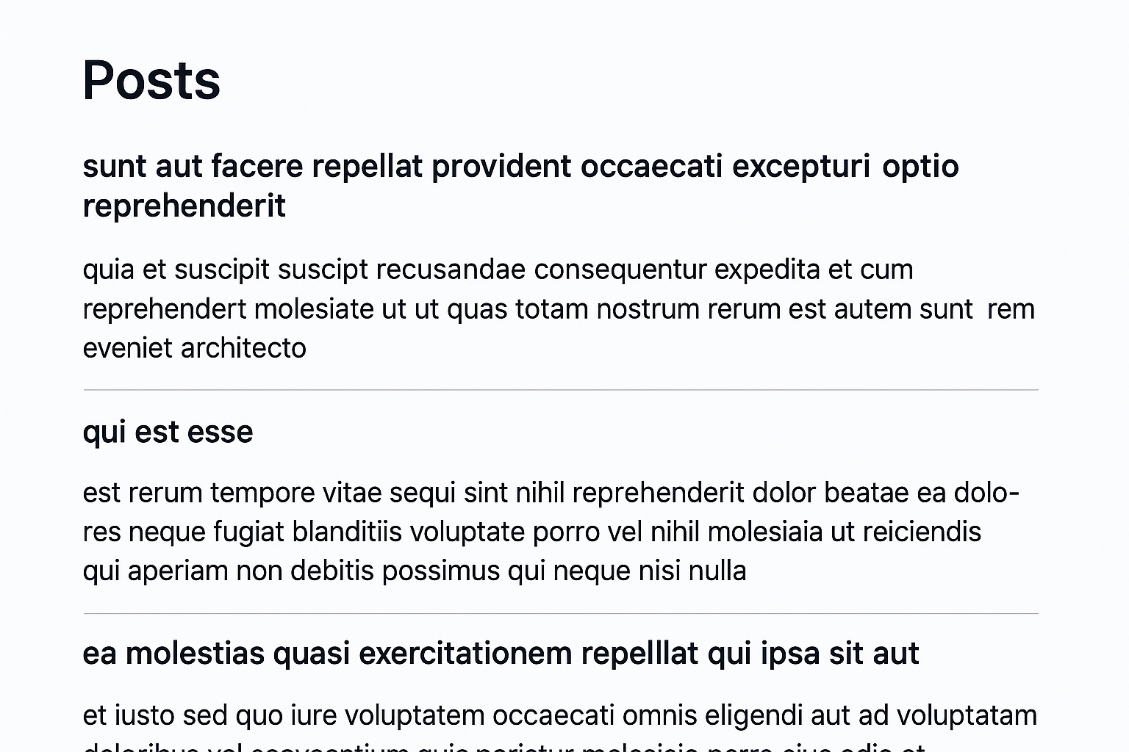

**5.REACTJS-HOL**

**CohortDetails.module.css**

.box {

width: 300px;

display: inline-block;

margin: 10px;

padding: 10px 20px;

border: 1px solid black;

border-radius: 10px;

vertical-align: top;

}

dt {

font-weight: 500;

}

.greenText {

color: green;

font-weight: bold;

}

.blueText {

color: blue;

font-weight: bold;

}

**CohortDetails.js**

import React from 'react';

import styles from './CohortDetails.module.css';

function CohortDetails({ cohort }) {

const status = cohort.status.toLowerCase();

const getHeadingClass = () => {

if (status === 'ongoing') return styles.greenText;

else return styles.blueText; // scheduled or other

};

return (

<div className={styles.box}>

<h3 className={getHeadingClass()}>{cohort.name}</h3>

<dl>

<dt>Started On</dt>

<dd>{cohort.startDate}</dd>

<dt>Current Status</dt>

<dd>{cohort.status}</dd>

<dt>Coach</dt>

<dd>{cohort.coach}</dd>

<dt>Trainer</dt>

<dd>{cohort.trainer}</dd>

</dl>

</div>

);

}

export default CohortDetails;

**App.js**

import React from 'react';

import CohortDetails from './components/CohortDetails';

const cohorts = [

{

name: 'INTADMDF10 -.NET FSD',

startDate: '22-Feb-2022',

status: 'Scheduled',

coach: 'Aathma',

trainer: 'Jojo Jose',

},

{

name: 'ADM21JF014 - Java FSD',

startDate: '10-Sep-2021',

status: 'Ongoing',

coach: 'Apoorv',

trainer: 'Elisa Smith',

},

{

name: 'CDBJF21025 - Java FSD',

startDate: '24-Dec-2021',

status: 'Ongoing',

coach: 'Aathma',

trainer: 'John Doe',

},

];

function App() {

return (

<div style={{ padding: '20px', border: '1px solid black' }}>

<h2>Cohorts Details</h2>

{cohorts.map((cohort, index) => (

<CohortDetails key={index} cohort={cohort} />

))}

</div>

);

}

export default App;

**output**

